14th Annual Archaeology Weekend
Anza-Borrego Desert State Park Visitor Center
Borrego Springs, California March 25-26, 2017 Free Admission

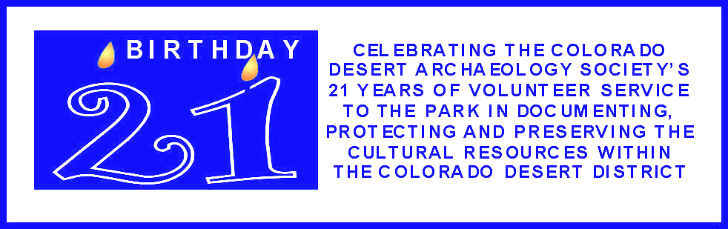

Saturday, March 25, 2017

Events - Visitor Center

9 - 4:30 Silent Auction at the Begole Archaeological Research Center. Bidding closes at 4:30 pm. Winning bids announced at 5:00
pm. (Winners need not be present) Funds raised are used to help preserve and protect the Park’s cultural resources.

9:30 - 4 Guided Tours of the Archaeology Lab & Silent Auction. Conducted by Colorado Desert Archaeology Society volunteers.
Groups depart from the Visitor Center front door approximately every half hour.

10-4:00 Native American Basket and Pottery Display. A Native American Bird Song singer will perform in the Plaza at noon.
Craft items will be for sale.

Pottery Making Demonstration and Kids’ Activities - Includes clay grinding with paddle and anvil construction techniques.
By CDAS Archaeology volunteers. (Clay will be available for spectator participation)

Demonstration Table on Uses of Native Plants for Food, Medicine and Construction by the Kumeyaay Tribes of San
Diego County & Baja California. By Suzanne Emery.

Pictograph Stories – Students of all ages will look at pictographs and then try to decode the pictograph story. They will then
create their own story on a rock to take home. By Ranger LuAnn.

4-5:00 Free Ice Cream Social - Ice cream sundaes and root beer floats at the Begole Archaeological Research Center.

Presentations – Discovery Room

10 – 11 The Genesis of the Colorado Desert Archaeological Society. The concept of a volunteer archaeology society modeled after
the Anza Borrego Desert Paleontology Society came to fruition in the spring of 1996--21 years ago when California State Parks’
first volunteer archaeological technicians were certified and began surveying and documenting the rich cultural landscape of the
Anza Borrego Desert. By Rae Schwaderer - Associate State Archaeologist, Monterey District

11- 12 We Couldn’t Have Done It Without You! How Colorado Desert Archaeology society’ volunteers made 21 years of projects
happen. Join retired Colorado Desert District Archaeologist Joan Schneider for a whirlwind tour of the archaeological projects,
large and small, made possible by the many, many hours and considerable skills of our trained volunteers from 2001 – 2011+

1 – 2 Activities in support of the Park’s Cultural Resources mission by Volunteers of the Colorado Desert Archaeology
Society. Site Stewardship Program by Carol Black, Use of UAV Photography to Record Archaeological Sites by Chuck
Bennett, and Cultural Features and Artifact Images by Sam Webb

2 – 3 Colorado Desert Archaeology Society: Carrying the Past into the Future. In CDAS’ future we anticipate a recommitment
the values of stewardship, field, lab and data support. We also anticipate growing as true Citizen Scientists by formulating
research questions, developing hypotheses, testing theories, and describing results. In this way we place ourselves a
participants in the future of CDD archaeology. By Robin Connors – Associate State Archaeologist, Colorado Desert District

3 – 4 Adapting Indian Ways to Survive and Thrive. Marshal and Tanya South lived 17 years on a remote mountaintop
in Blair Valley after the Great Depression. They adapted a lifestyle based on their knowledge and interpretation of Indian
lifeways, romanticizing the experience for their Desert Magazine readers. A Pre-Field Trip Presentation.
By Diana Lindsay – an award-winning author and historian

Sunday, March 26, 2017

Events – Visitor Center

9 – 12 Native American Basket and Pottery Display. (Craft items for sale)

9:30 - Guided Tours of the Archaeology Lab.
12 Groups depart Visitor Center front door approximately every half hour.

10-12 Pottery Making Demonstration - Includes clay grinding with paddle and anvil construction techniques.
By CDAS Archaeology volunteers. (Clay will be available for spectator participation)

Demonstration Table on Uses of Native Plants for Food, Medicine & Construction by the Kumeyaay Tribes of San
Diego County & Baja California. By Suzanne Emery.

Presentations - Discovery Room

10-11 From a Ranger’s Point of View: Working Together Towards Protecting our Cultural Heritages- A Historical
Perspective. By Ranger Steve Bier (This program is especially for KIDS & their parents)

11-12 A 21-Year Overview of Colorado Desert Archaeology Society Volunteer Work in Support of the Park’s Cultural
Resource Management Plan, with posters, photos, and displays. By CDAS volunteer – Steve Russell

Field Trips

08:30 Clark Lake Petroglyphs: This is a moderate hike of approximately 3 miles round trip to visit the Clark Lake Petroglyph Site.
01:00 The hike across the desert floor crosses the braided wash system which flows out of Rockhouse Canyon. The petroglyphs are
associated with the Cahuilla People and were pecked into the heavy desert-varnished boulders at the north end of Clark Lake.
The trip will depart from the Pegleg Monument at 8:30 AM and will return by 12:30-1:00 PM. 4WD is necessary for this trip.
(Limited to 15 people - $5.00 fee) Trip led by CDAS volunteer Chuck Bennett.

9:00 Mine Wash Indian Village Join CDAS Archaeology Technician and volunteer Site Steward Don Endicott for half day trip back in
2:00 time to the Mine Wash archaeological site, which was occupied and used most intensively by the Kumeyaay people around
1100 years ago and again in the 1600s ("Late Prehistoric" Period). During our walk over relatively gentle open desert we will
observe a variety of features associated with seasonal habitation, food gathering, and food preparation. Archaeological features
we will see including bedrock milling and grinding features and examples of the mysterious pecked cupules found throughout the
region. We will meet at the Park Visitor Center’s back parking area at 9:00) and carpool to the Mine Wash site. High clearance
vehicles are preferred. (Limited to 20 people - $5.00 fee) There is a primitive restroom a short distance south of the highway
junction but no facilities are available at the site. Please be prepared with suitable footwear, hats, sunscreen, your own water,
and food for lunch. The field trip will conclude back at the Visitor Center at 2:00 pm.

9:30 Ghost Mountain in Blair Valley by Diana Lindsay. Step back in time as we climb Blair Valley’s Ghost Mountain and look at the
2:00 plant resources found there that the Kumeyaay and Marshal and Tanya South collected and harvested. We will discuss why the
Souths retreated to this waterless mountaintop and considered it a spiritual home. It was the inspiration for 9 years of monthly
articles for Desert Magazine and the creation of two western novels that incorporated local legends and even the use of the
sacred Datura plant. Meet in the back parking lot of the Visitor Center for a 9:30 departure to Blair Valley. Estimated time of
return would be 2:00. Car pooling is recommended. (Limited to 25 people - $25.00 fee, which includes Marshal South Rides
Again – his two Anza-Borrego novels in one volume) Bring a snack, water, lunch, hat, sunscreen. Trekking poles optional. Hill
is steep. Total hiking distance up to 3 miles. Possible side trip, depending on time.

Pre-registration required for the field trips
For detailed information and reservations call ABF at 760-767-0446 ext 1003.
During Archaeology Weekend: Check for last-minute field trip openings at the CDAS table in front of the
Visitor's Center. Depending on field trip, there is a $5 - $25 fee. Wear hiking shoes and bring hat and water.

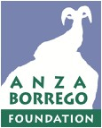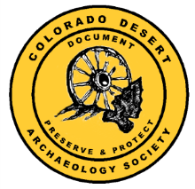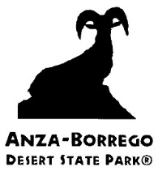

Colorado Desert Archaeology Society

