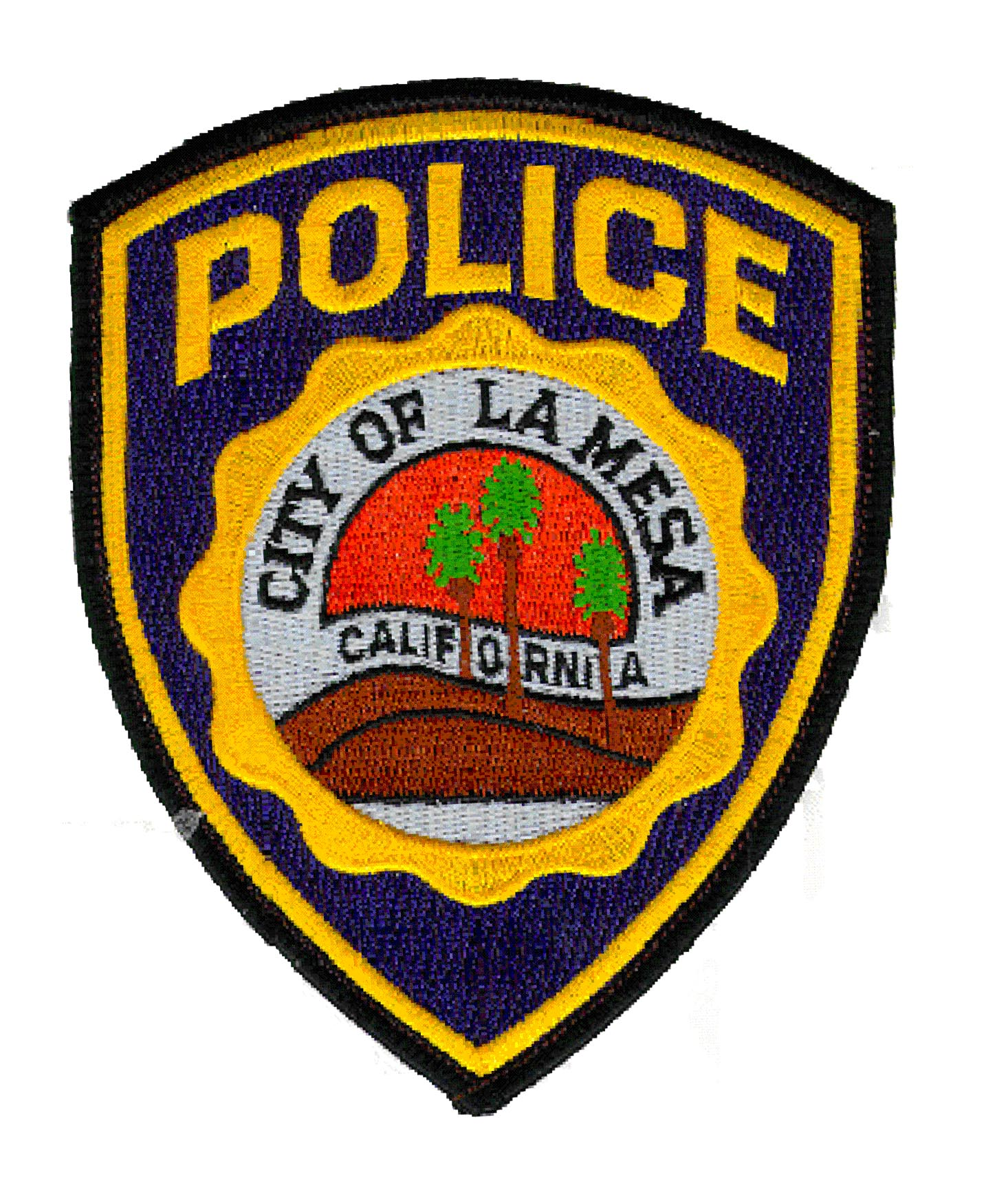
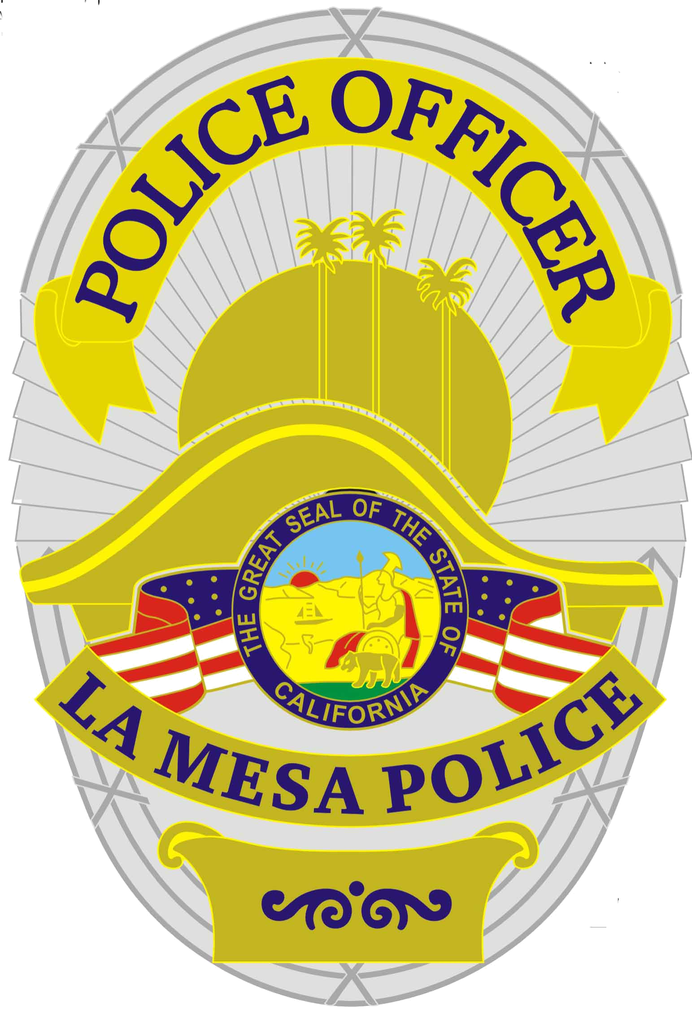

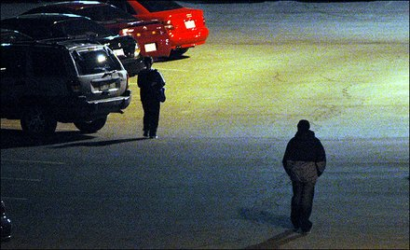
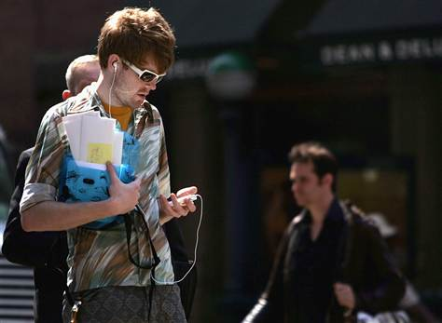
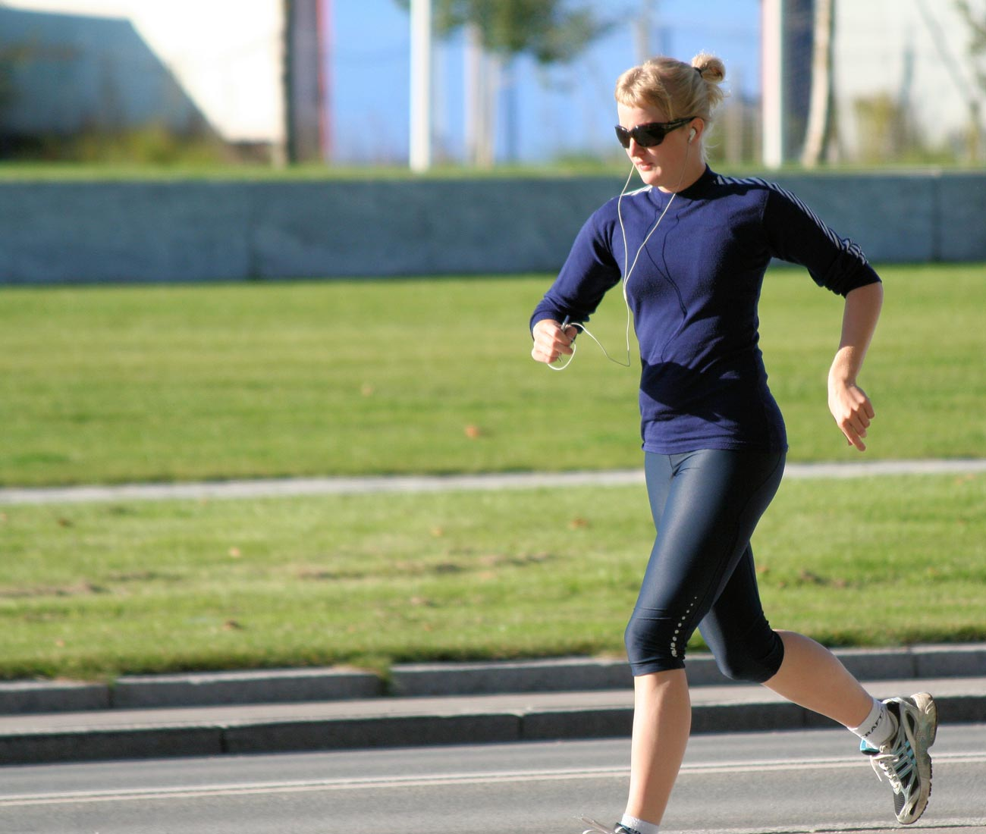

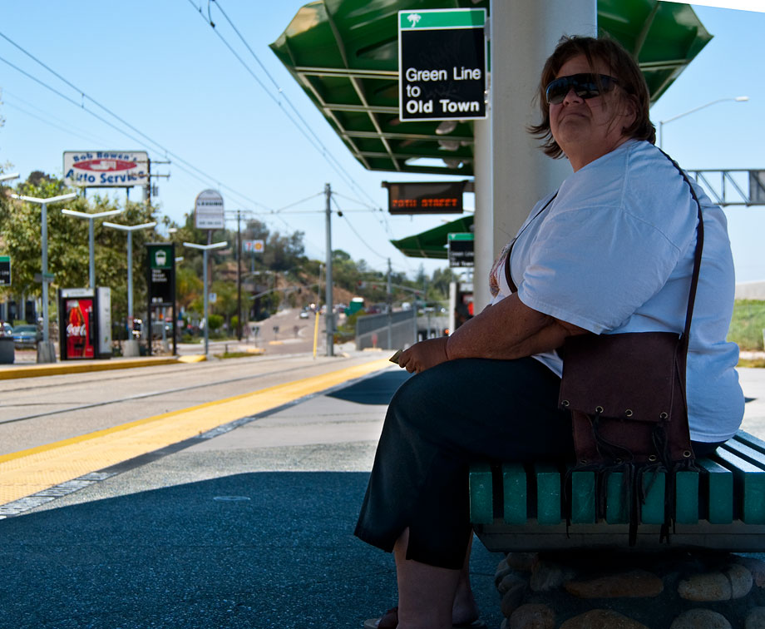

How Safe Are You?
The La Mesa Police Department is hosting a Personal Safety Awareness Seminar on Thursday, March 1, 2012 from 5:00p-6:30p at the Police Station located at 8085 University Avenue.
The Class is Open to the Public but Space is Limited and Reservations are Encouraged.
Contact Sergeant Brian Stoney at (619) 667-7555 e-mail bstoney@ci.la-mesa.ca.us
In 2010, an estimated 18.7 million U.S. residents age 12 or older were victims of violence or property crimes.
Are you always aware of your surroundings? If not, how do you develop awareness and avoidance skills?
What do street predators look for in a victim? How do you avoid fitting that victim profile?
What do you do if you find yourself in a dangerous situation? How do you quickly escape danger in the event of an assault?
You owe it to yourself to learn new skills, actions, and habits for awareness, vigilance, avoidance, defensive interventions and escape strategies…and we’ll teach them to you!

This class will consist of both lecture and demonstration taught by the Police Department’s Defensive Tactics Instructors.

