MISSING PERSON AT RISK

Date/Time: | 10-09-2013/1946 hrs |  | 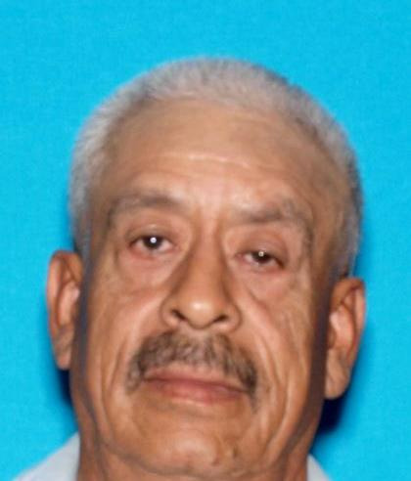
Last Name | Domingues
First Name: | Salvador
Age: | 67
Gender: | M
Height: | 5-7
Weight: | 140
Eye: | Brown
Hair: | White
Complexion: | Light
Race: | Hispanic
Clothing: | Black Jacket/Sky Blue pants
Date of Birth | 02/02/1946
Date of Last Contact: |  | 10-09-1946

On 10/09/2013, at 1946 hours, Salvador DOMINGUES, boarded the trolley at 352 S. Marshall Ave in El Cajon, CA. DOMINGUES was separated from his spouse at the trolley station. DOMINGUES has Alzheimer’s Disease. DOMINGUES does not have any identification or money in his possession. DOMINGUES is a Spanish speaker and only knows his name.

