December 11, 2012

The Honorable Dianne Jacob, Supervisor, 2nd District

The County of San Diego

County Administration Center

1600 Pacific Highway

San Diego, CA 92101

**Covert Canyon – Staff Report Recommendation to Deny Appeal**

Dear Supervisor Jacob,

There are three substantial problems with the Staff Recommendation.

Principally; Staff makes a recommendation to deny appeal on the basis of not what is written in the Zoning Ordinance, but on what a departmental administrator “thinks” it might mean. The ordinance itself is quite explicit in its definition of Law Enforcement Services; and it does not include fire arms training of the sort being planned. This is demonstrated by the report abstract below. Nor does the applicable ordinance section provide latitude for personal interpretation.

Our legal system is based upon evidentiary processes, not on what any of us may “think”.

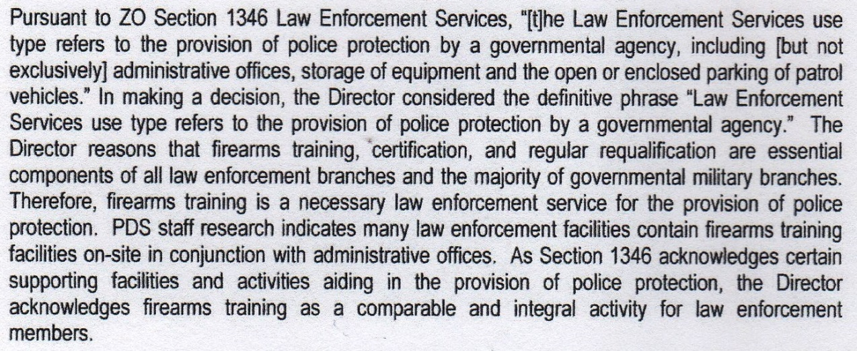.

Secondly; The Zoning Ordinance section on agricultural land use was written in a time and place when it cannot be reasonably imagined that its drafters nor the then Board of Supervisors could have anticipated the increasingly militarization of law enforcement tactics and weaponry; everything from S.W.A.T. operations and the use of dangerous, highly lethal, long range anti-personnel weapons. That is also the case for a plethora of “new” law enforcement training such as “live-tissue trauma training" involving the killing of pigs as part of medical training for corpsmen.

None of this has an intrinsic connection with agricultural land use.

Thirdly; The staff report seems to “think” that the “fire arm training” at Covert Canyon will be “safe” because of law enforcement’s participation. Staff proposes limiting the bore of weapons to 50 caliber. This is not meaningful.

Long distance, high impact anti-personnel weapons are less than 50 caliber; and 50 caliber is used in long range weapons intended for the destruction of materials!

My current experience working with the U.S. Navy on the conservation of land for the protection of the public from “fire arms training” and other activities at the Navy SEALs mountain training base, Camp Michael Monsoor in La Posta, leads me to “think” differently to the staff report.

The Navy is in the process of securing many 1,000s of acres of both public and private lands in and around the 1,000 acre Camp Michael Monsoor in a proactive effort to in part protect the public at large on nearby public lands and the residents in the area on their private lands.

Covert Canyon is 150 acres in size with the “shooting ranges” a 100 yards from public land (Cleveland National Forest) and perhaps 200 yards from the nearest private parcel having a home. Para-military law enforcement fire arms shooting intended for Covert Canyon will be more dangerous given the proximity of public lands and private residences. This activity and its inherent danger are not consistent with the character of the Alpine community; nor with public safety.

My own experiences as a fire arm enthusiast and former “Expert Marksman” member of the National Rifle Association comes to mind. I have a scar near my eye were I was struck by an errant round during a controlled rifle match inside of a purposely built shooting range operated a major city police department. Accidents happen.

The sorts of activities conducted in the past and planned for Covert Canyon have no place within the community of Alpine. “Convenience” for local law enforcement training does not over-ride the primary role of San Diego County government in protecting the public.

As clearly, explicitly written, the zoning ordinance is not applicable with respect to a land use intended at Covert Canyon that never could have been envisioned at the time of its writing. Perhaps the zoning ordinance needs reconsideration?

In matters of land use that are inherently dangerous and lethal, the execution of an ordinance should not be based upon what an administrator “thinks” it may mean!

Lastly, in its deliberations and vote on the appeal, the Planning Commission also had difficulty in concluding a clear administrative directive. Votes against the appeal were initially split; as were votes for the appeal. This is a clear argument against the matter being led forward by a process based upon what an administrator “thinks” as opposed to what the ordinance clearly says.

Please support the appeal against fire arms training at Covert Canyon.

Yours respectfully,

George Barnett, Alpine

619-659-0345 & [BigG88882@cox.net](mailto:BigG88882@cox.net)