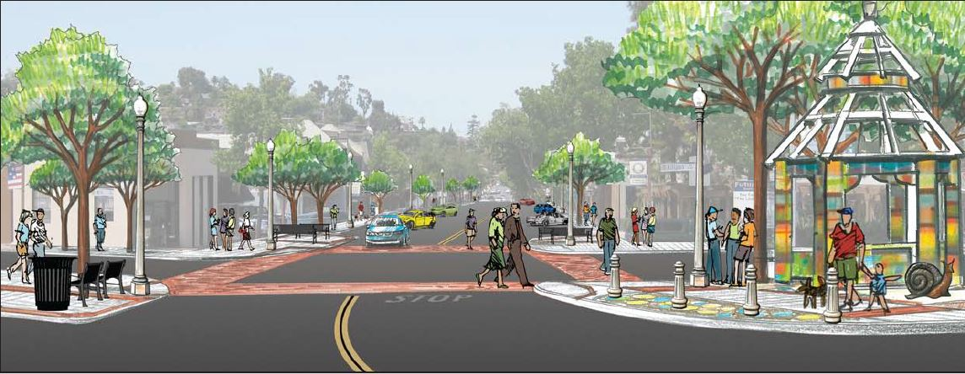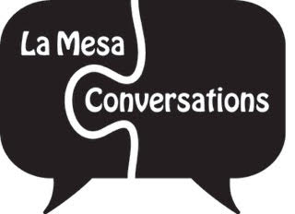

**The Future of Downtown La Mesa**

***Wednesday, January 27, 2016***

## **Moderator:**

## **Barry Jantz, CEO of Grossmont Healthcare District & Retired La Mesa City Councilman**

## **Panelists:**

## **David E. Witt, City Manager of the City of La Mesa**

## **Christopher D’Avignon, CEO of Land and Design Inc.**

## **Shon Finch, Development Professional at Fairfield Residential**

## **Mary England, CEO of La Mesa Chamber of Commerce**

***Join the conversation!***

**6:00 pm to 7:30 pm**

At the Masonic Lodge at **4731 Date Avenue, La Mesa, CA**

(*located in downtown La Mesa, across the street*

*from the La Mesa-Spring Valley School District building*)

*La Mesa Conversations Presents:*

*Join the conversation!*

***www.lamesaconversations.org***