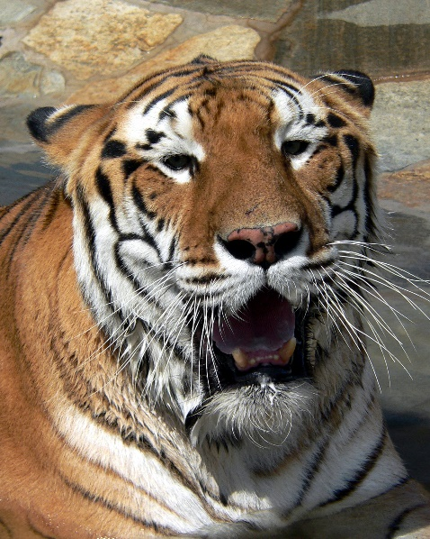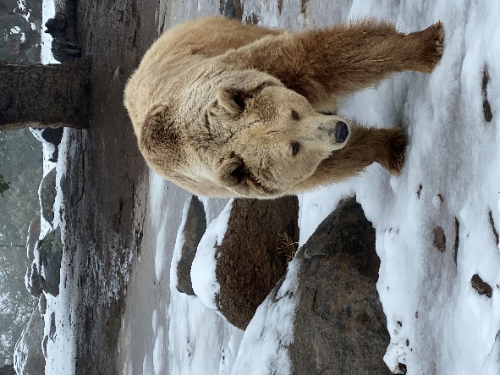
ALPINE’S LIONS TIGERS & BEARS SEEK DONATIONS TO FEED THEIR ANIMALS DURING COVID-19 SHUTDOWN
By Rebeca Jefferis Williamson
File photo by Miriam Raftery
March 31, 2020 (Alpine) -- Local tigers and other rescued exotic animals at Alpine’s Lions Tigers & Bears Animal Sanctuary need your monetary help. The tigers, and more, need to keep eating even during today’s economic hard times induced by the COVID-19 crisis.
With millions in stay-at-home lockdown locally and nationally, money from attendance at the sanctuary has evaporated. The facility is closed to the public due to the pandemic. The COVID-19 shutdown has also forced postponement or cancellation of fundraising events for the foreseeable future.
You can donate at https://www.lionstigersandbears.org.
Founder Bobbi Brinks set up the rescue facility and dedicated it to providing a safe haven for abused and abandoned exotic animals for life.
Unlike the infamous facility featured on “Tiger King,” Lions, Tigers and Bears is a no-kill and no-breeding sanctuary.
Lions, Tigers and Beras also provides an educational forum to end the exotic animal trade. The facility has the highest level of accreditation from the Global Federation of Animal Sanctuaries and the American Sanctuary Association.
The Alpine sanctuary is offering glimpses into their sanctuary via their Facebook page, facetime, and other social media platforms.
A tiger, bear, or lion lover can only enjoy watching them on Facebook, but also help them keep afloat until reopening by donating a small or large monetary gift.
Below are how various donations, small to large, and how they can help Maverick the tiger and other animals housed there. As they state-- it is literally a lifeline for these animals you know and love.
- $20 is two days of food for Conga the leopard
- $100 is medicine for Bakari for a week
- $200 is a week worth of food for Maverick the tiger
- $600 is a month's supply of flea medicine for our 9 bears
Lions Tigers & Bears is a federally recognized 501(c)(3). Tax ID # 33-0938499/
They are asking donors, from any area, to help them “Hang in There” during these economic hard times.
Various fundraising events will be held in the coming year such as “Wild in the Country,” once events are allowed by the state and county again. Check their website for changes in scheduling due to COVID-19.
You can learn more at https://www.lionstigersandbears.org/ . Lions, Tigers and Bears is also on Instagram, Facebook, and twitter.

