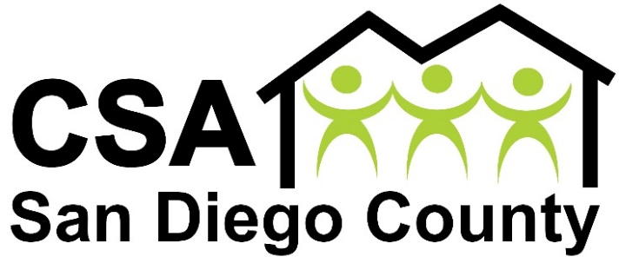
OFFICERS

President

Jesus Pacheco

MEMBERS

Besma Coda

Yusef Miller

JoAnn Fields

Leticia Munguia

Griselda Delgado

Executive Director
Estela De Los Rios
“We are Your Neighbors. We are Your Community. We are Your Resource.”
A; 327 Van Houten Ave, El Cajon, CA 92020 P: 619.444.5700 F: 619.447.5761 W: www.c4sa.org

April 17, 2023

Dear J.M. Kaplan Fund grant reviewers:

I am writing to support East County Media’s J.M. Kaplan Innovation Grant proposal to create a Social Justice News and Resource Center on the East County Magazine website.

I am the Executive Director of the Center for Social Advocates San Diego County. As a civil rights and Latino rights leader, I helped organize national immigrant marches and worked on a national study on labor trafficking. I have known Miriam Raftery, Executive Director of East County Media and Editor of East County Magazine, for many years through her past and current journalism endeavors.

East County Magazine is a highly reputable and widely read news site dedicating to giving a voice to the voiceless in our region. East County Media is the nonprofit that Miriam established in 2018 to financially support and sustain East County Magazine’s award-winning journalism. Through the years, her reporting has called attention to the plight of people in need across our region, from Latino immigrants to war refugees from Iraq, Syria and Afghanistan, as well as homeless populations. This includes her news site as well as the East County Magazine radio show that Miriam hosts on KNSJ, the network for social justice.

As a border region, San Diego County has long had a large Latino immigrant community with residents from Mexico, South and Central America. In recent years has also taken in more refugees from around the world than nearly any other county in America, including many refugees from the Middle East, Africa, Asia, and most recently, Ukraine. Housing costs are high, so most of these new Americans are in East County. There are also undocumented immigrants and asylum seekers camped at our border, caught in limbo trying to reach the U.S. due to ever-changing federal immigration policies. San Diego County also has one of the nation’s highest homeless populations.

All of these people face challenges that are often not being met by governmental agencies. There are many nonprofits and community groups seeking to aid immigrants and/or refugees, but efforts are often not coordinated and some groups are not aware of the resources offered by other organizations, nor are immigrants and refugees provided with adequate information on where to seek help.

Miriam’s proposal to create a central resource center for social justice highlighting resources for immigrants, refugees, the homeless and others in need, as well as to spotlight various groups and individuals through a series of interviews, podcasts, webinars and interactive online forums is greatly needed in our region. This idea has the potential to help many people and create a model that could be implemented in other areas.

Thank you for your consideration of this much-needed proposal.

Sincerely,

Estela de Los Rios
Executive Director, Center for Social Advocates San Diego County

